Module Assembly - TC API - Generate Files with Alternative Representations Of the Submission Deployment Guide

Revision History
Author | Revision Number | Date
isv | 1.0 | 04/26/2014

Deployment Instructions 3
1. Organization of Submission 3
2. Application Setup 3
2.1 Configuration 3
2.2 Build Scripts Setup 4
3. Database Setup 4
4. Deployment Instructions 4
5. Starting 5
6. Verification 5
7. Resource Contact List 10

Deployment Instructions

Organization of Submission

The submission follows directory structure provided below:

docs

Contains this document which is the Deployment Guide for the Module Assembly - TC API - Generate Files with Alternative Representations Of the Submission assembly.

tc-api

Contains the configuration, libraries, sources for TopCoder Node JS API application developed/updated in the course of this assembly. This directory replicates the application development distribution structure and includes only updated and new files.

Application Setup

The submission is expected to be deployed to the following environment:

JRE 1.7
NodeJS 0.10.21
Informix DS 11.0
Git
Heroku

This assembly was developed against following Git commit hash:

URL: https://github.com/cloudspokes/tc-api.git
Hash: 977f0c6a79adf985ba779feb70c67b552b8c5b89

Configuration

Following new configuration parameters have been defined by this assembly:

Property Name | File property is stored | Example Setting
config.watermark.filePath | tc-api/config.js | A path to watermark image. The actual value may be set by WATERMARK_FILE_PATH environment variable.
config.watermark.fileType | tc-api/config.js | A type to watermark image. Defaults to PNG. The actual value may be set by WATERMARK_FILE_TYPE environment variable.
config.watermark. baseImageTransparency | tc-api/config.js | A base image transparency for watermark image. Defaults to 50. The actual value may be set by WATERMARK_BASE_IMAGE_TRANSPARENCY environment variable.
config.watermark. overlayImageTransparency | tc-api/config.js | An overlay image transparency for watermark image. Defaults to 100. The actual value may be set by WATERMARK_OVERLAY_IMAGE_TRANSPARENCY environment variable.
config.watermark.overlayImageRed | tc-api/config.js | Overlay image red color weight for watermark image. Defaults to 0. The actual value may be set by WATERMARK_OVERLAY_IMAGE_RED environment variable.
config.watermark. overlayImageGreen | tc-api/config.js | Overlay image green color weight for watermark image. Defaults to 0. The actual value may be set by WATERMARK_OVERLAY_IMAGE_GREEN environment variable.
config.watermark. overlayImageBlue | tc-api/config.js | Overlay image blue color weight for watermark image. Defaults to 0. The actual value may be set by WATERMARK_OVERLAY_IMAGE_BLUE environment variable.
config. galleryIds | tc-api/config.js | An array listing the IDs for challenge categories which require preview galleries to be generated.
config.jvm.minMemory | tc-api/config.js | Minimum memory to be allocated by JVM (like 128m)
config.jvm.maxMemory | tc-api/config.js | Maximum memory to be allocated by JVM (like 512m)

Build Scripts Setup

The TopCoder NodeJS API application provides the following commands which are to be used:

- npm install – installs TopCoder NodeJS API application
- npm rebuild – rebuilds TopCoder NodeJS API application
- npm test – runs Mocha-based unit tests.

Database Setup

To add missing ID generation sequences and create sample challenge to be used for testing/reviewing purposes run following SQL scripts against target database:

tc-api\test\test_files\design_image_file_generator\test-data-submission.sql

Deployment Instructions

- Set up necessary infrastructure for TopCoder NodeJS API based on your environment See following page for details (click the link corresponding to your OS):
  - https://github.com/cloudspokes/tc-api/wiki/_pages
- Clone TopCoder NodeJS application from Git repository https://github.com/cloudspokes/tc-api.git to your local machine. See chapters suitable for your local environment at following page for details (click the link corresponding to your OS):
  - https://github.com/cloudspokes/tc-api/wiki/_pages
- Copy the code from tc-api directory of this submission into working copy cloned from Git repository at step above
- Download final fix for TC API - Port UnifiedSubmissionValidator Logic For Analyzing Submitted File assembly from http://apps.topcoder.com/forums/?module=Thread&threadID=817135&start=0&mc=3 and copy tc-api/common/unifiedSubmissionValidator.js file from it to working copy cloned from Git repository at step above
- Set up environment variables to suit the current environment. See https://github.com/cloudspokes/tc-api/wiki/Configure-Environment-Variables In particular setting designSubmissionsBasePath and designSubmissionTmpPath in tc-api/config.js file is important. Also config.watermark.filePath property must point to an existing file to be used for watermarking the generated images.
- Install TopCoder NodeJS API application using npm install command. See chapters suitable for your local environment at https://github.com/cloudspokes/tc-api/wiki/_pages for help (click the link corresponding to your OS)

Starting

- Install the TopCoder NodeJS API application
- Start ActionsHero server instance hosting TopCoder NodeJS API application (see Start Server chapter at page matching your current OS at https://github.com/cloudspokes/tc-api/wiki/_pages)

Verification

- Setup node-jslint tool using command like npm install jslint -g and check formatting for the updated code using commands like:

jslint --nomen common/designImageFileGenerator.js
jslint --nomen config.js
jslint --nomen actions/designImageFileGeneratorTest.js
jslint --nomen routes.js

There must be no code formatting errors displayed:

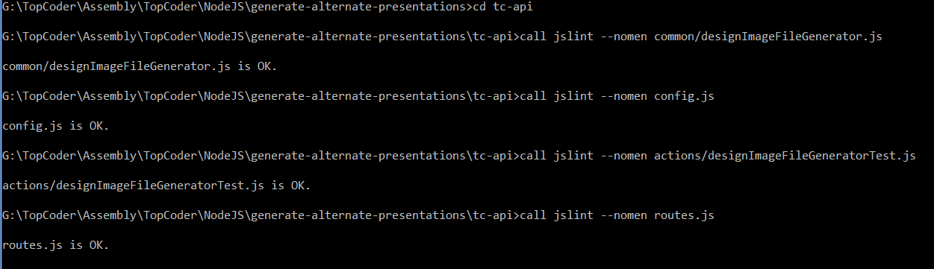

- Open tc-api\test\test_files\design_image_file_generator\testDesignImageFileGenerator.html in browser window (you may need to update the "action" attribute of "form" element to point to host where TC API application is deployed), select desired file for uploading to server (you may use tc-api\test\test_files\design_image_file_generator\sample_submission.zip for example) and submit the form:



The test action must respond with correct result:

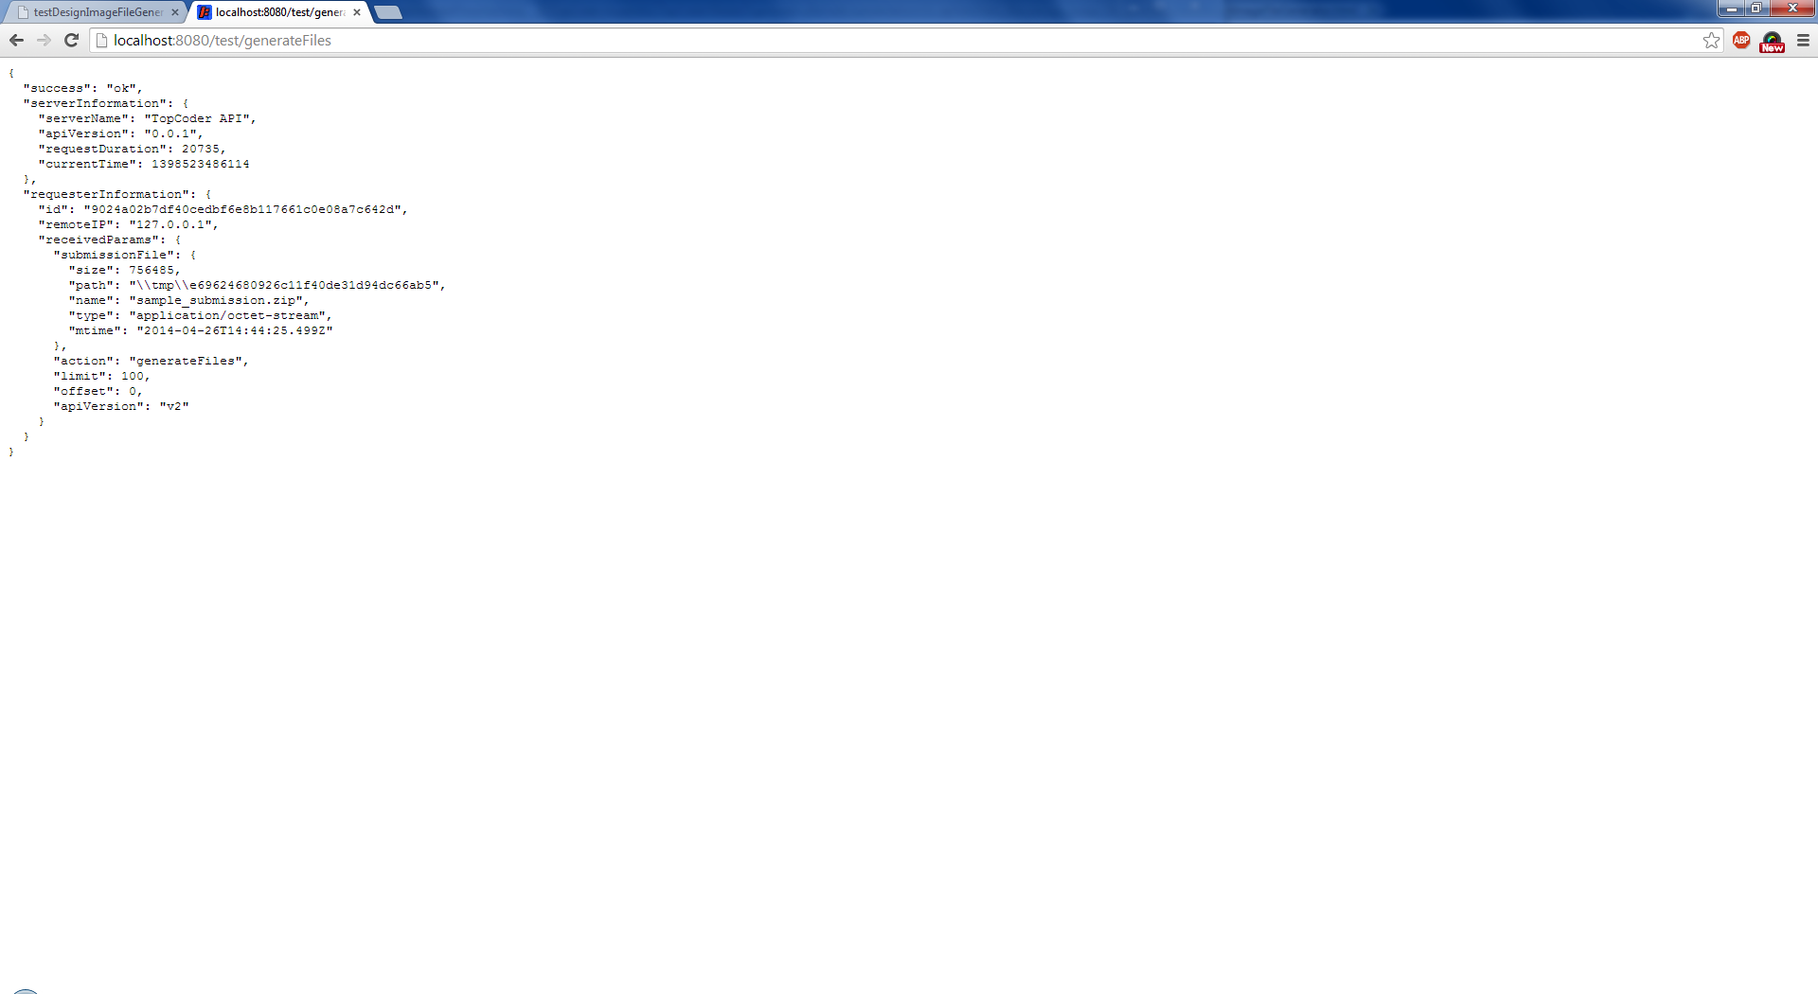

The server log should indicate on successful execution of action and may look like:

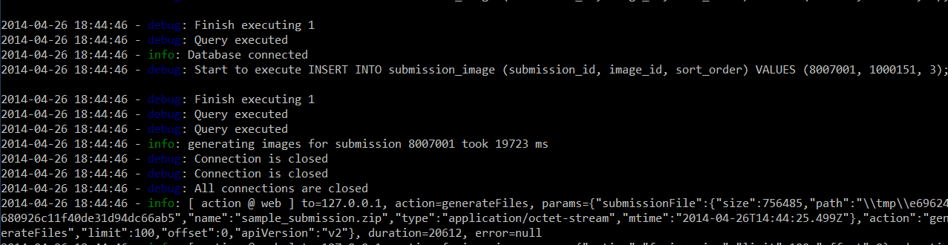

- Check the content of directory where generated files must have been put to (see tc-api/config.js# designSubmissionsBasePath configuration property)

The generated files must appear in that directory:

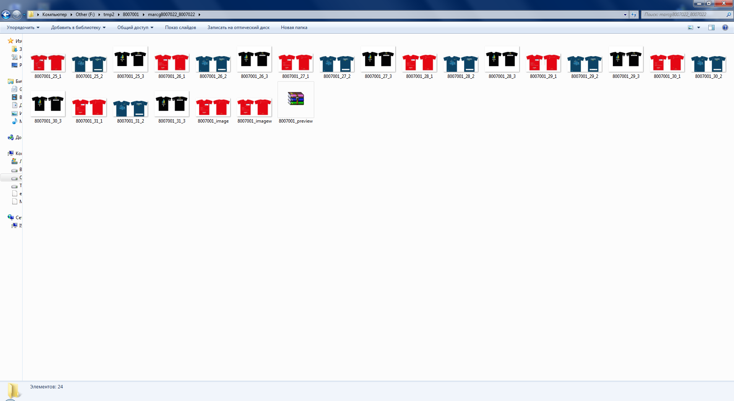

- Check the content of image and submission_image tables in database using commands like:

DATABASE tcs_catalog;
SELECT * FROM image;
SELECT * FROM submission_image;

The records for generated images must be inserted into those table:

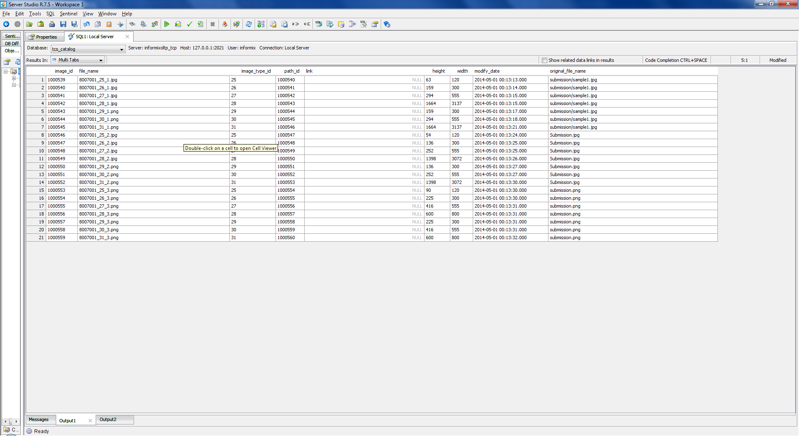

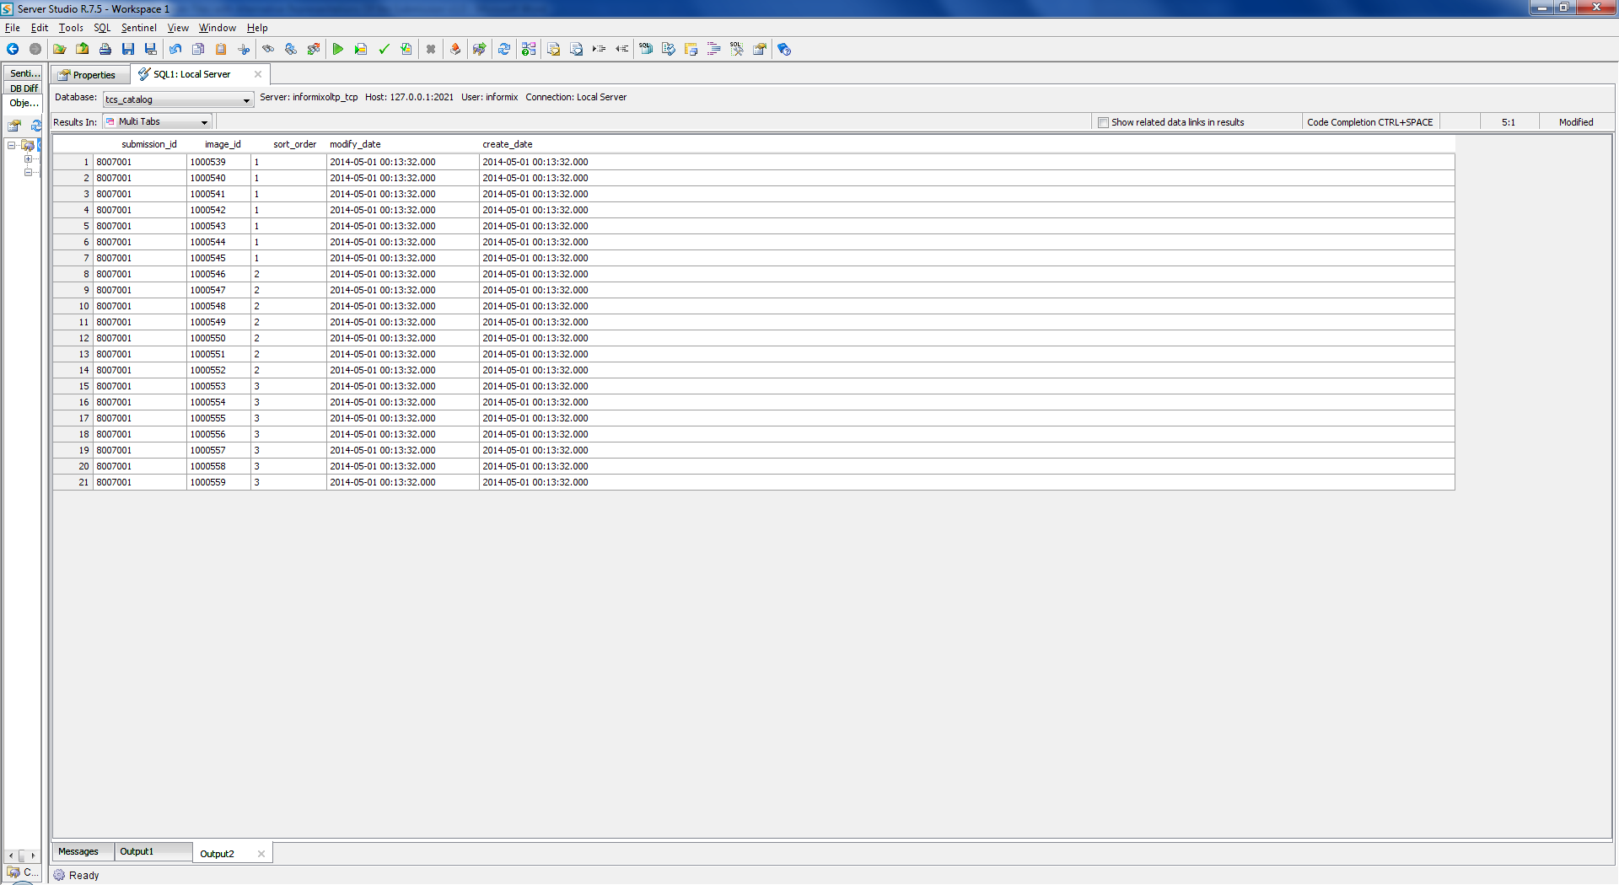

- Deploy application to Heroku by following the instructions at https://github.com/cloudspokes/tc-api/wiki/Heroku-Deployment-Guide

The application must be deployed successfully.
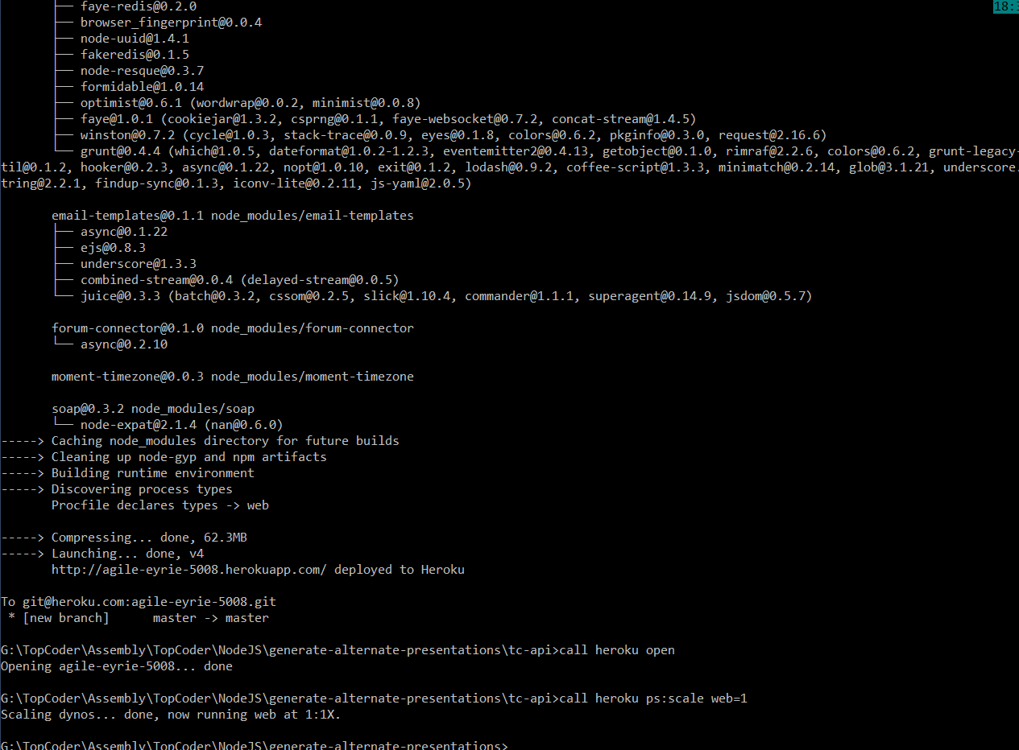

Resource Contact List

Name | Resource Email
isv

